ARYAN POC LIQUIDITY MODEL (APLM)
A Session-Based Volume Profile & Liquidity Framework
for Intraday XAUUSD Trading
Professional Research Report
Author: Aryan Govindbhai Patel
Quant Research Intern – 2Cents Capital Limited
Research Period: March 2026 – June 2026
Market: XAUUSD | Timeframe: 5 Minute

Contents
Abstract 3
Introduction 3
Market Theory 3
Strategy Construction 3
Performance Metrics 3
Trade Case Studies 4
Risk Management 6
Limitations 6
Conclusion 6

Abstract
The Aryan POC Liquidity Model (APLM) is a discretionary trading framework that combines Fixed Range Volume Profile, Point of Control (POC), Smart Money Concepts, and session liquidity analysis. The model focuses on identifying high-probability opportunities during the New York session.

Introduction
Most retail traders focus on indicators, while institutions focus on liquidity. APLM was developed around the concept that the Point of Control acts as a liquidity magnet and institutional reference level.

Market Theory
Liquidity is created during the Asian session, expanded during London, and often released through directional movement during New York. The model seeks to align with this sequence.

Strategy Construction
A Fixed Range Volume Profile is drawn from 5:30 AM IST to 5:30 PM IST. The Point of Control, Value Area High, and Value Area Low are extracted. POC serves as the primary decision-making level.

Performance Metrics
Metric | Result
Market | XAUUSD
Timeframe | 5 Minute
Backtest Period | Mar 2026 - Jun 2026
Trades Tested | 100+
Win Rate | ~66%
Average Risk : Reward | 2.2 : 1
Max Consecutive Losses | 2
Expected Value | ~ +1.11R per trade

Trade Case Studies
The following examples illustrate POC interaction, liquidity capture, and directional expansion during the New York session.
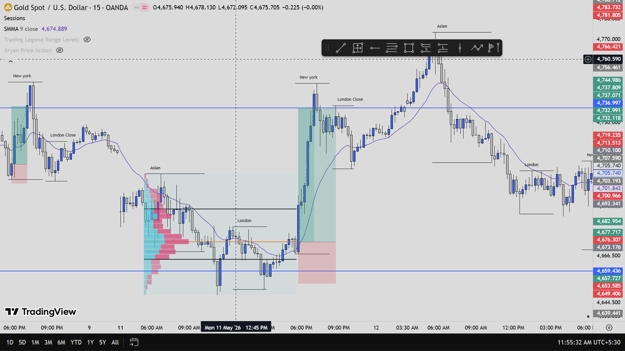
Example trade setup demonstrating the Aryan POC Liquidity Model.
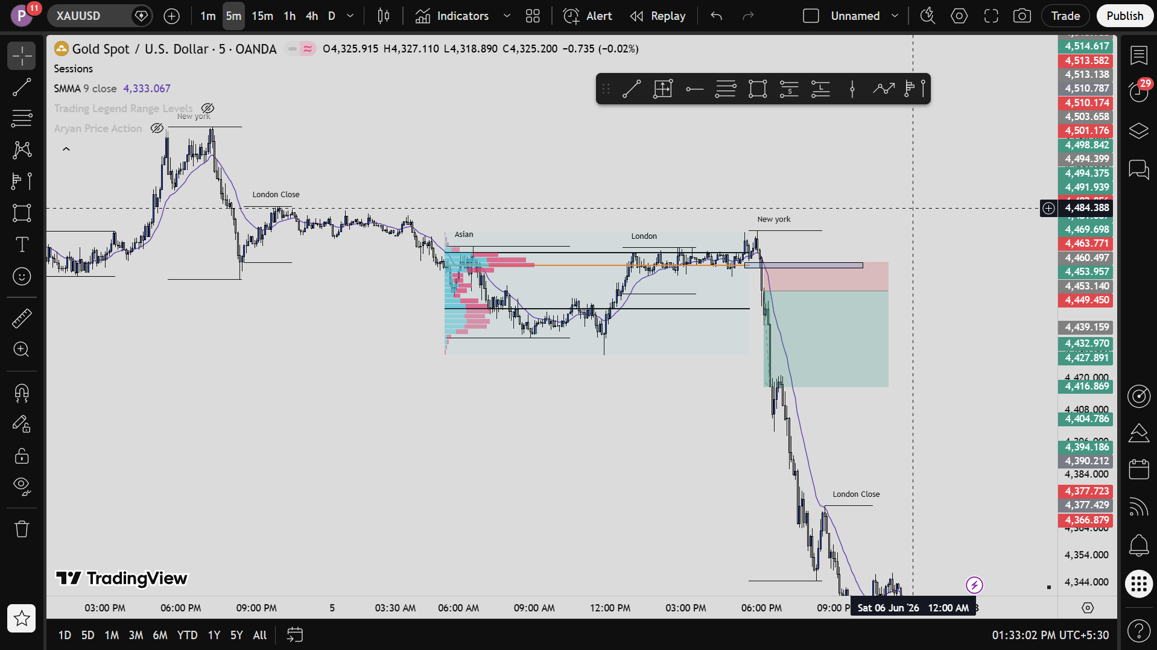
Example trade setup demonstrating the Aryan POC Liquidity Model.
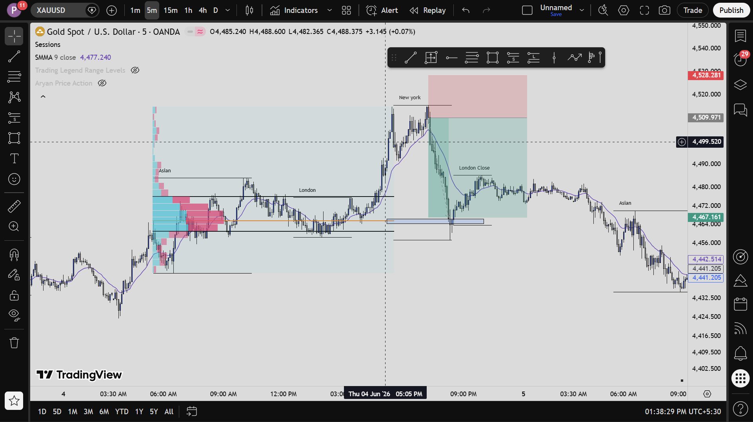
Example trade setup demonstrating the Aryan POC Liquidity Model.

Risk Management
Recommended risk per trade is 1%. Stop losses generally range between 100–200 points based on structure and volatility. Profit objectives focus on 1.5R–2R to maximize long-term compounding.

Limitations
The framework contains discretionary elements and requires experience in liquidity interpretation. Performance may decline during low-liquidity environments and major news events.

Conclusion
APLM demonstrates that combining volume profile analysis with liquidity concepts can create a repeatable framework for intraday XAUUSD trading. The model produced approximately 66% win rate with a 2.2:1 reward-to-risk profile during manual testing.

